# Coursera Capstone

# The Battle of The Neighbourhoods

## Introduction

As part of the final module for the IBM Data Science Professional Certificate, I am tasked with using all skills, technologies and methods learnt throughout the 9 module course, alongside utilising the foursquare API and any relevant accessible data, to experiment with real world problems in the data science world.

For this week, I will be providing:

* A description of the problem and a discussion of the background.
* A description of the data and how it will be used to solve the problem.

## Discussion and Background of the Business Problem

BrightMindsDS is a new tech company that specialises in Machine Learning and Big Data. The start-up originally began in the CEO's garage in Kent, with 4 employees trying to do everything. Since landing 6 new clients they have had just cause to expand the business and move their office to a more professional location in London, England. The founder of BrightMindsDS requires at least 10 more employees and wants to find a suitable office space to encourage growth, innovation and creativity.

"Companies that care more about health and welfare of their employees enjoy better engagement, while employees are less often sick, meaning productivity receives a boost. With this in mind, a new report has encouraged employers to think more about how they can make their employees more healthy." (1)

"Although success can bring happiness, to create great work, the employees’ health, wellbeing and happiness is the most important factor." (2)

With this in mind, the CEO wants to create a nice atmosphere for his new employees. He believes that his employees' health and wellbeing will be a main driver towards the company's success. When looking at possible locations for the new office, things like:

* Can it be accessed via local transport?
* Are there any gyms nearby?
* Is there a nice park/open space nearby?
* Are there good coffee shops nearby for lunch?
* Are there good bars/nightclubs to socialise in after work?

will be considered. A minimum of 2 of these requirements is ideal for a new office location.

In order to obtain an ideal location for the new office space, the London area is explored through clustering and segmentation based on London Post code data and fulfilment of the requirements.

(1) <https://www.consultancy.uk/news/18201/companies-that-invest-in-employee-health-enjoy-higher-engagement>

(2) <https://inside.6q.io/employee-health-wellbeing-matters/>

### Target Audience

Although this project looks at a new Tech company, a variety of companies would be interested in the methods used in this project:

- Any start up or small company might find this useful when looking to expand.

- Any large company that is hoping to open a new office in an unknown location may use this to compare different places.

- This project is so adaptable that many types of venues, e.g. cafes, restaurants, museums, nightclubs, etc, can use the methods from this project to open in a different location.

This project’s main audience is anyone who is looking to open a new space in a different location to where they are currently situated.

## Data Preparation

The data for this project will be collected from the Foursquare API and Wikipedia. From Wikipedia I can obtain a list of all of the boroughs in London, alongside their postal codes. Using Foursquare I can obtain relevant information about the selected areas.

London synonymous to the Greater London Area, is the capital and largest city of England and of the United Kingdom. It encompasses a total area of 1,583 square kilometres (611 sq mi), an area which had a population of 7,172,036 in 2001 and a population density of 4,542 inhabitants per square kilometre (11,760/sq mi). There are 32 Boroughs in Greater London as well as the 'City of London' principal division. There are 8 Post Code areas; N, NW, SW, SE, W, WC, E and EC. And 121 post code districts. As to be expected this is a very large data set.

Data can be found here: <<https://en.wikipedia.org/wiki/List_of_areas_of_London> >

Basic research has led me to focus on East London, i.e. Boroughs with the Post Code starting with E or EC. I have made this decision as this is where the 'East London Tech City' can be found. It is said to be a great location to build your company.

"Some ask why they should set up there. I say the cluster is where your business is most likely to succeed. Your partners clients, investors will be there. You’ll be able to hire people. You’ll come up with great ideas." (3)

Using python libraries and frameworks I will be able to scrape these wiki pages to obtain this relevant data;

* Location
* Borough
* Post-town
* Post Code
* Dial Code
* Grid reference

This data will be filtered to contain only East London locations.

Using the Geocoder package, I can get the Latitude and Longitude for each of these locations.

The Foursquare API allows application developers to interact with the Foursquare platform. The API itself is a RESTful set of addresses to which you can send requests, so there's really nothing to download onto your server. You can currently request output in XML or JSON format.

Using the Foursquare API, I will be able to make specific requests about set locations. I hope to collect a vast amount of data to help fulfil BrightMindsDS requirements and answer their questions.

Depending on how much data is available will also help determine whether a location is suitable. Again, this will be relevant to the questions; e.g:

The client will want at least 5 coffee shops nearby but will only require 1 park/open space to be close to the office. If there are only 2 gyms that shouldn’t be a problem compared to if there were only 2 bars in the local area etc.

Data I hope to obtain:

* Type of venue
* Distance from neighbourhood
* Latitude
* Longitude

Looking at the Foursquare API data, I will hopefully be provided with relevant, personal and reliable data. Using these factors will help to decide where the best location will be to set up the new BrightMindsDS office.

(3) <https://www.mbymontcalm.co.uk/blog/all-you-need-to-know-about-east-london-tech-city/>

### Data Cleaning and Feature Selection

I was able to obtain the relevant information about the neighbourhoods in London by scraping a Wikipedia page. This was carried out using the BeautifulSoup library.

Beautiful Soup is a Python library for pulling data out of HTML and XML files. It works with your favourite parser to provide idiomatic ways of navigating, searching, and modifying the parse tree. The prettify() method will turn a Beautiful Soup parse tree into a nicely formatted Unicode string, with a separate line for each tag and each string.

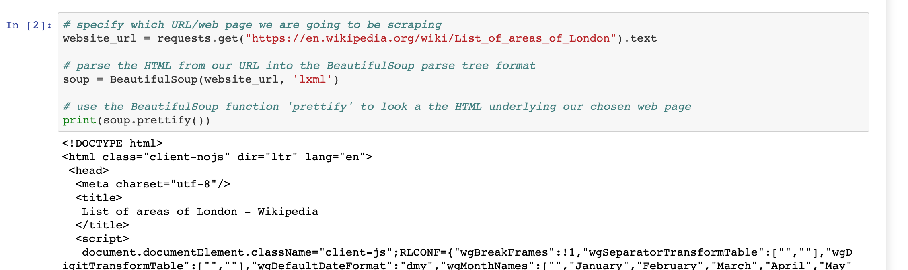

Using soup.find() I could then look through the html for the corresponding table class ‘wikitable sortable’.

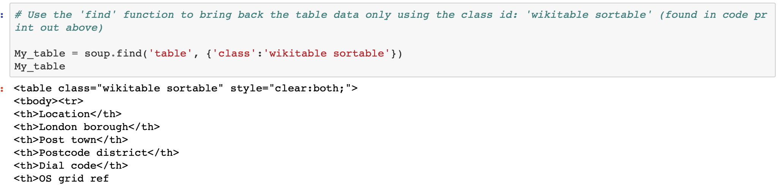

Looping through this data, I was able to create a data frame.

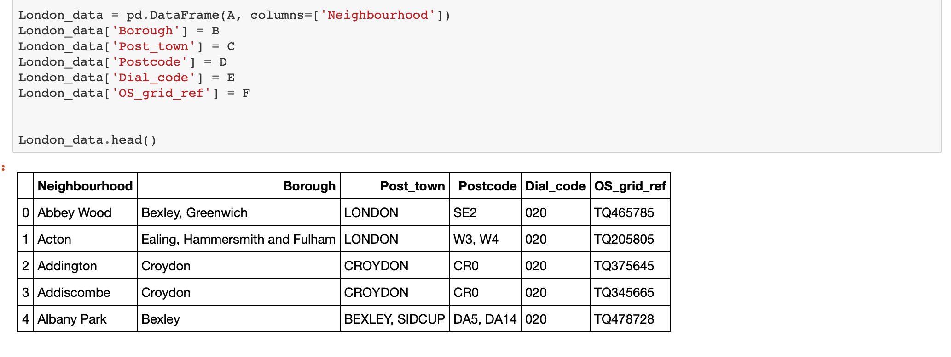

As can be seen, some locations are associated to two postcodes, e.g. Acton; W3 and W4. The data is **cleaned** by spreading the postcodes to multi-rows and assigning the same values from the other columns. Aside from this, the data collected contained no NULL values or duplicated rows.

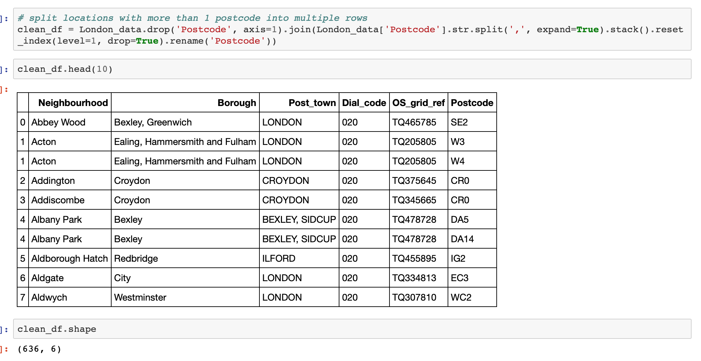

After data cleaning I was left with 6 columns and 636 rows of data.

### Feature Selection

Feature Selection is one of the core concepts in machine learning which hugely impacts the performance of your model. The data features that you use to train your machine learning models have a huge influence on the performance you can achieve.

Feature Selection is the process where you automatically or manually select those features which contribute most to your prediction variable or output in which you are interested in. Having irrelevant features in your data can decrease the accuracy of the models and make your model learn based on irrelevant features.

Benefits of Feature Selection:

· **Reduces Overfitting**: Less redundant data means less opportunity to make decisions based on noise.

· **Improves Accuracy**: Less misleading data means modeling accuracy improves.

· **Reduces Training Time**: fewer data points reduce algorithm complexity and algorithms train faster.

Looking at the data collected from wikipedia, it was clear that not all of it was needed. Phone codes would have no impact on the comapany's choice of location so the *Dial_code* column could be removed. Grid references although helpful when using a map, are not required to obtain the longitude and latitude of the neighbourhoods. That can be done with the relevant libraries and Postcodes. This lead to the *'OS_grid_ref'* column being removed also.

This left the columns: *Neighbourhood*, *Borough*, *Post_town* and *Postcode*.

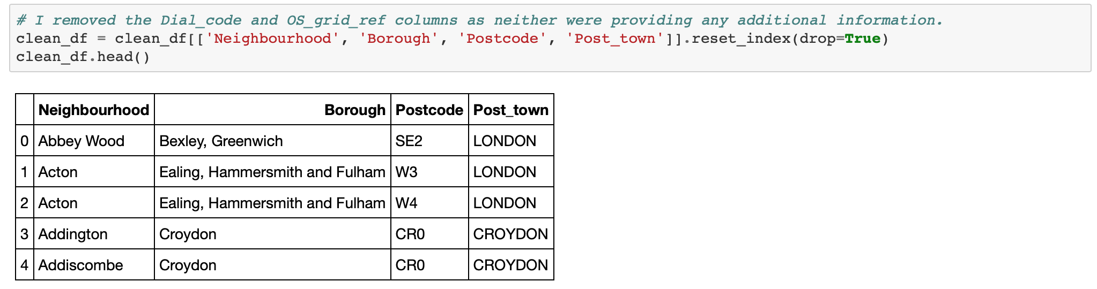

### Obtain Coordinates of each location and use folium to visualise the data

To be able to visualise this data, I need the latitude and longitude of each of the locations in my clean London data frame. To do this I will use the Geocoder package. This package is a simple and consistent geocoding library written in Python. It is used with the *arcgis_geocoder*.

Geocoding is the process of transforming a description of a location—such as a pair of coordinates, an address, or a name of a place—to a location on the earth's surface. You can geocode by entering one location description at a time or by providing many of them at once in a table. The resulting locations are output as geographic features with attributes, which can be used for mapping or spatial analysis.

<https://desktop.arcgis.com/en/arcmap/latest/manage-data/geocoding/what-is-geocoding.htm>

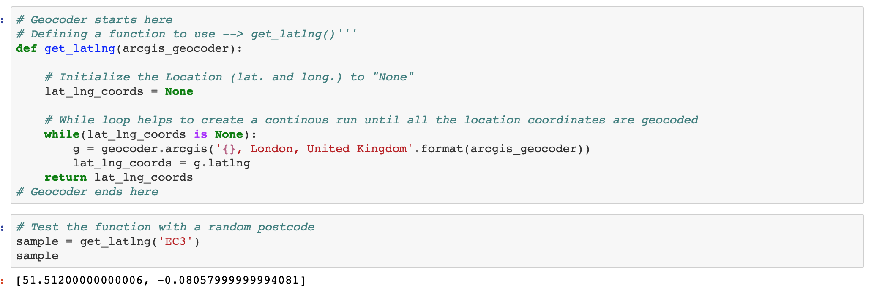

I trialed the function with a random postcode to see if coordinates where being returned correctly. This was then tested by using geocodefarm. This reverses the geocode generated coordinates to return a possible address and post code. As can be seen, the post code matches showing that the function is working correctly.

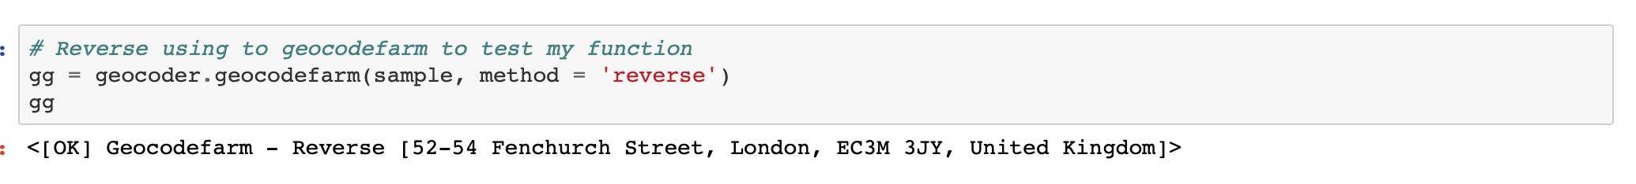

It can now be used on my clean data frame. Results are as shown:

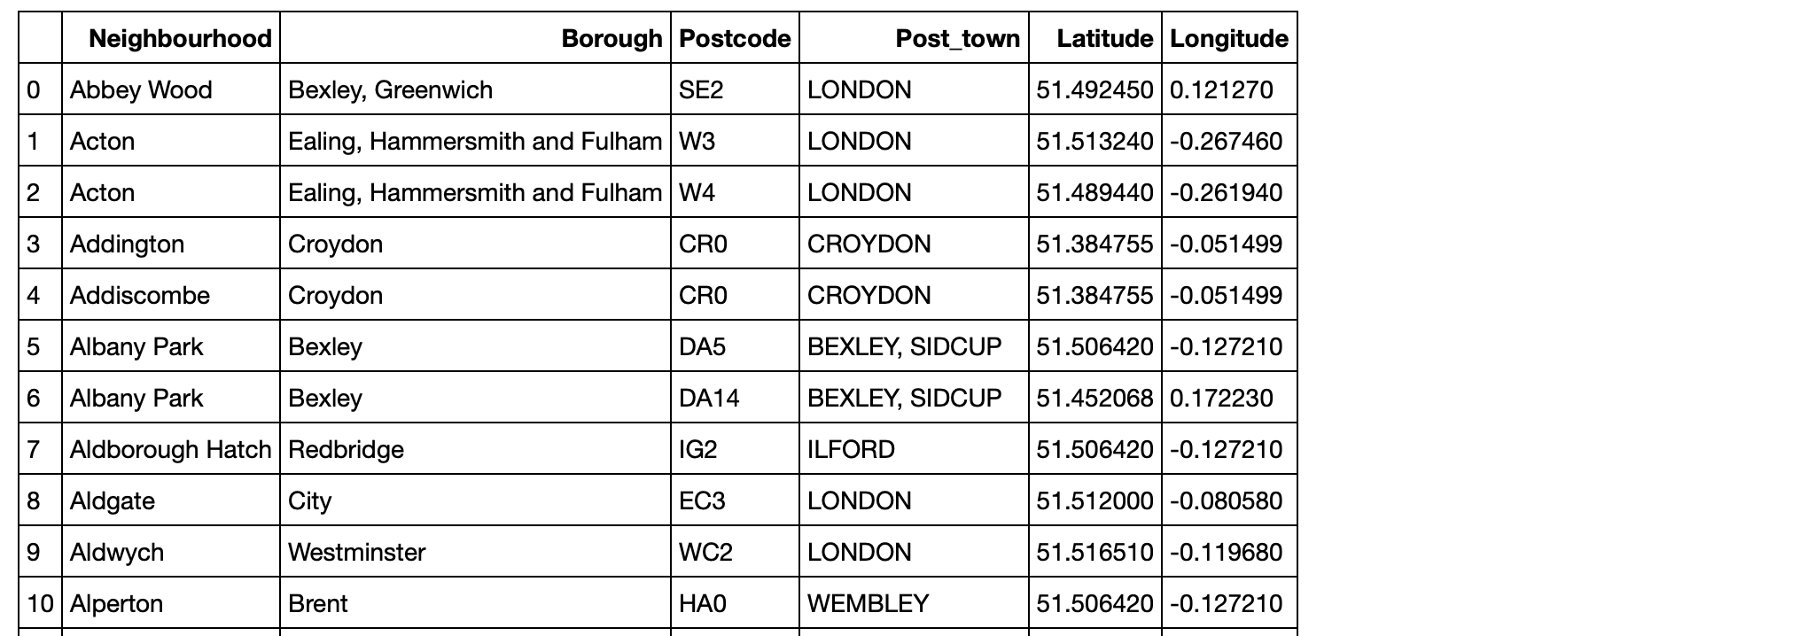

### Data Visualisation

Now I had obtained the latitude and longitude of every neighbourhood in my data set.

Using this data alongside the folium visualisation library, I can create a map of London with the neighbourhoods superimposed on top. This is a helpful visual to show how the data is spread out over the City and see if any observations can be made from it. Clicking on the blue markers reveals the name of each neighbourhood, the respective borough and the Postcode.

I also need the latitude and longitude of London. This is technically the 'starting point' for the map. I can obtain this by using geocoder.

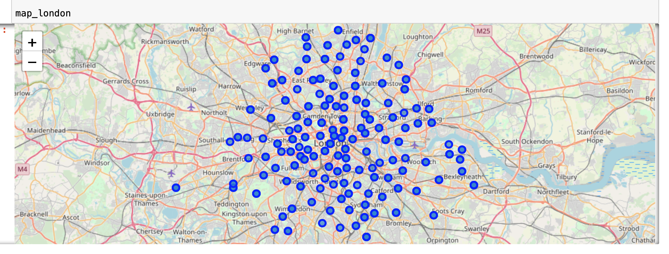

This map provides a nice overview of the data. It is interactive which can help determine where neighbourhoods are in relation to each other. However, due to the limitations of the free Foursquare option, I need to decrease the size of my df meaning further **cleaning** is required.

After running some basic analysis, I can see that there are 288 unique postcodes and 636 rows of data. This is a great data set but too large for this project. The foursquare API collects data relevant to all neighbourhoods in the dataframe. Obtaining venue information with regards to each neighbourhood will be too much information to work with. To reduce the size appropriately without removing any relevant data, I am going to focus on the **East London** postcodes only, as discussed above. To do this, the data set needs to be cleaned and filtered again. I have decided to do this by:

* Only keeping data where the Post_town = LONDON
* Only taking data where the Postcode contains 'E'

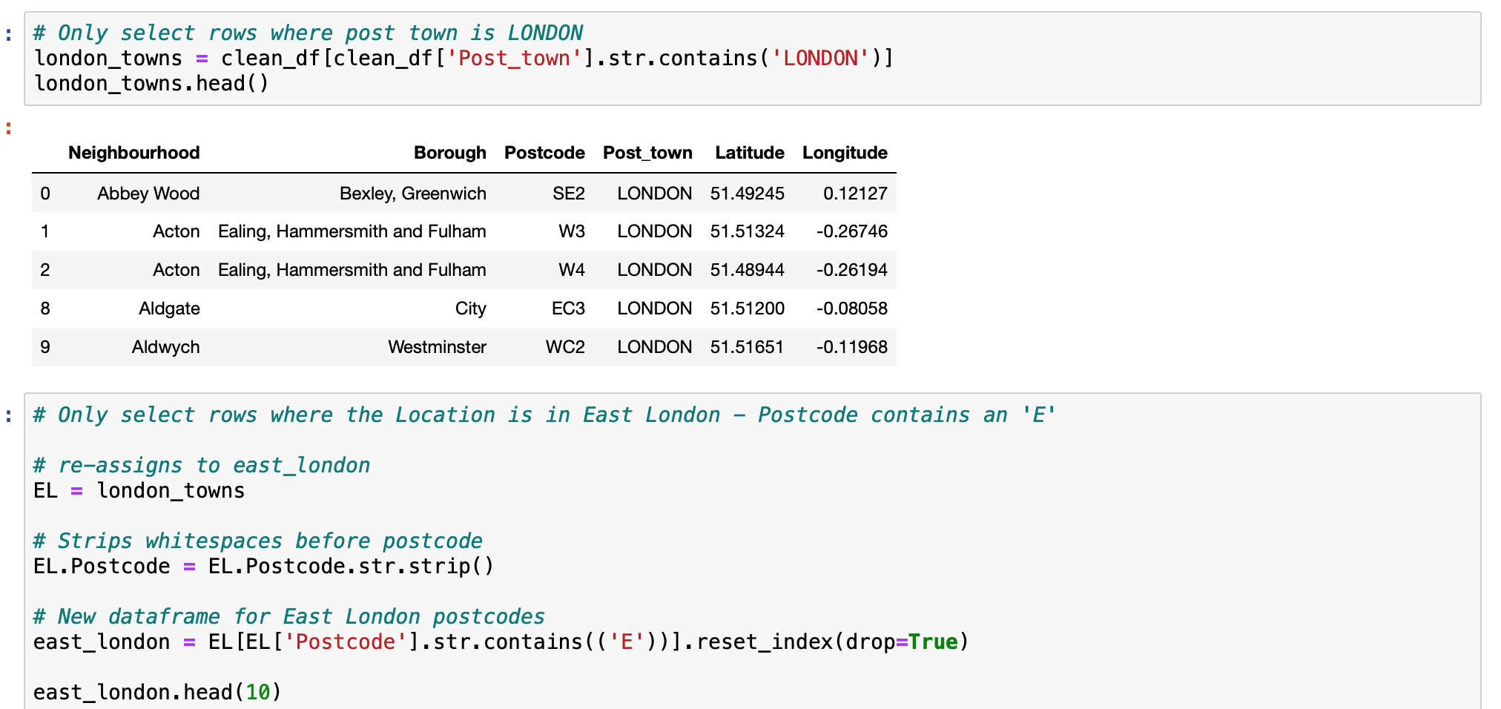



156 rows is a much smaller data set to be using, hopefully making visuals clearer and the data easier to understand. All rows now only look at neighbourhoods situated in the East of London. Recreating the map with this new data set helps add context to where I am considering for a new office space.

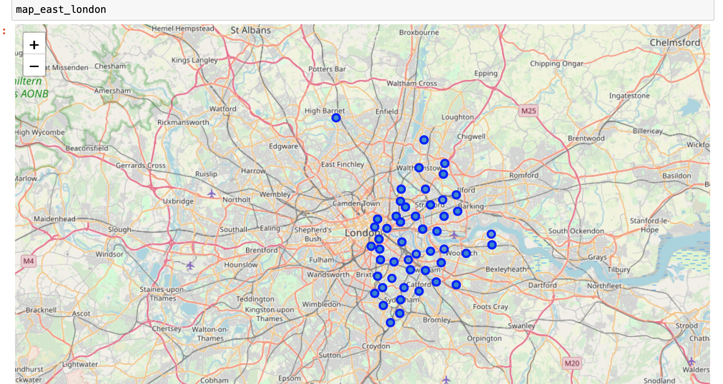

## Foursquare

### Now we look at using the Foursquare API.

### Foursquare is a social location service that allows users to explore the world around them.

### The Foursquare API allows application developers to interact with the Foursquare platform. The API itself is a RESTful set of addresses to which you can send requests, so there's really nothing to download onto your server.

### Foursquare requires unique and personal credentials linked to my account. Using the API request, I can obtain the nearest 150 venues per each neighbourhood using their respective coordinates.

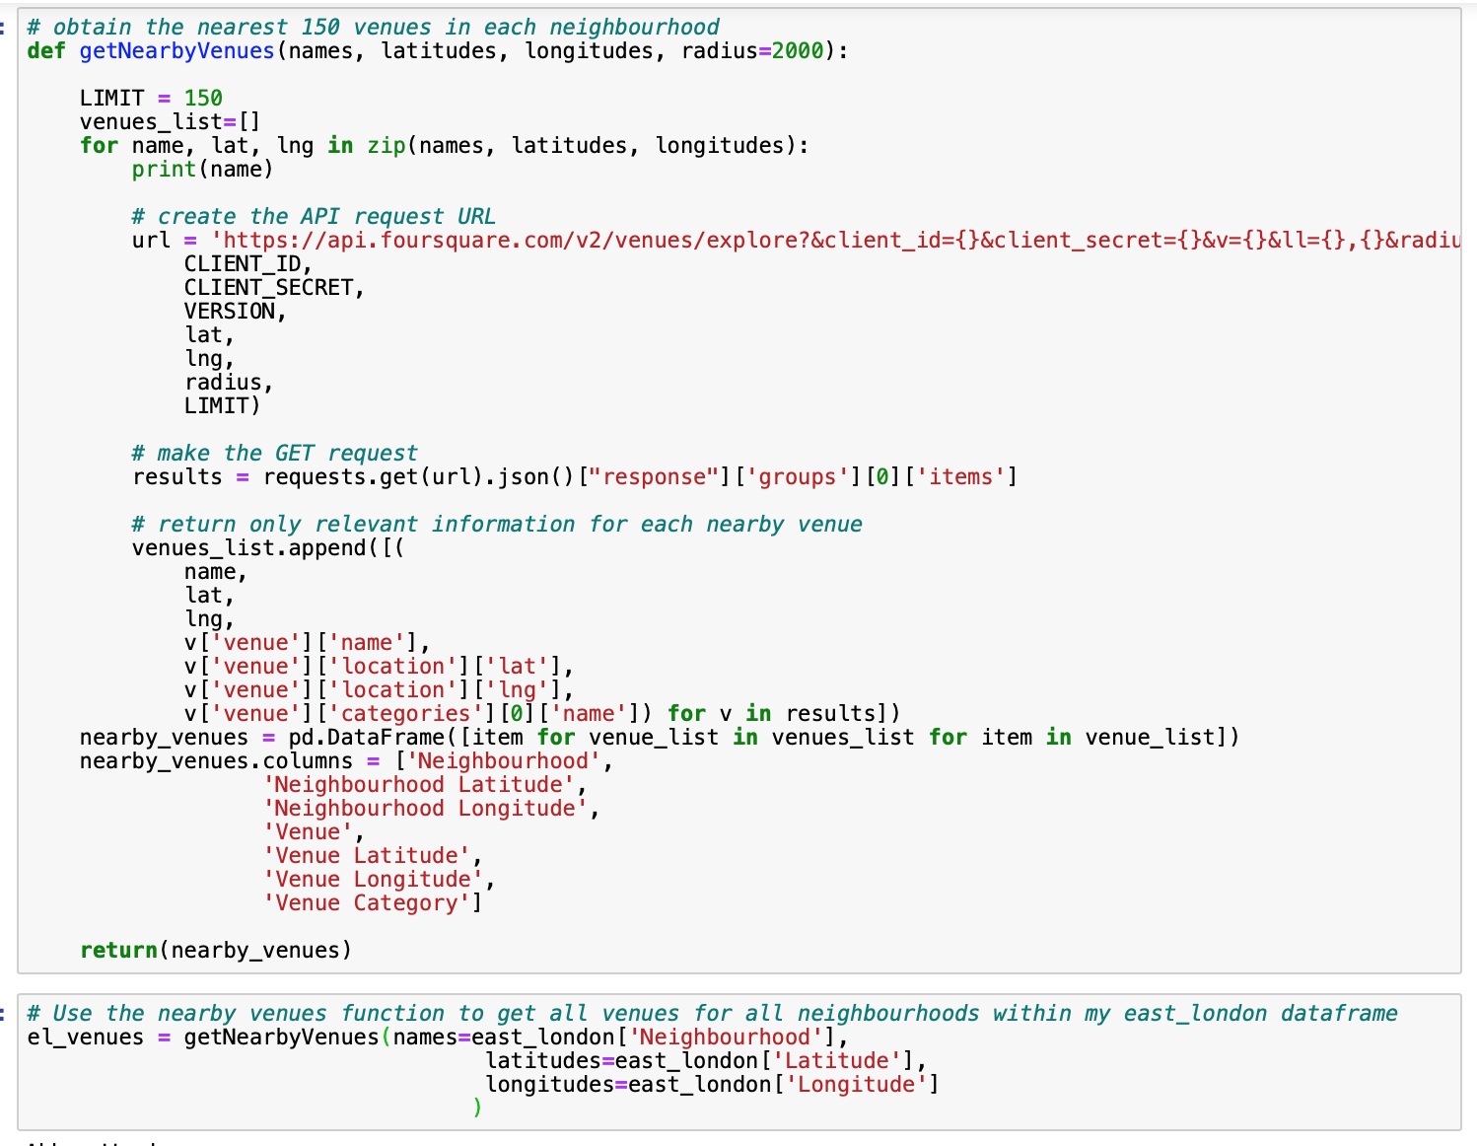

### The data returned consists of:

### - Neighbourhood

### - Neighbourhood latitude

### - Neighbourhood longitude

### - Venue

### - Venue latitude

### - Venue longitude

- Venue Category

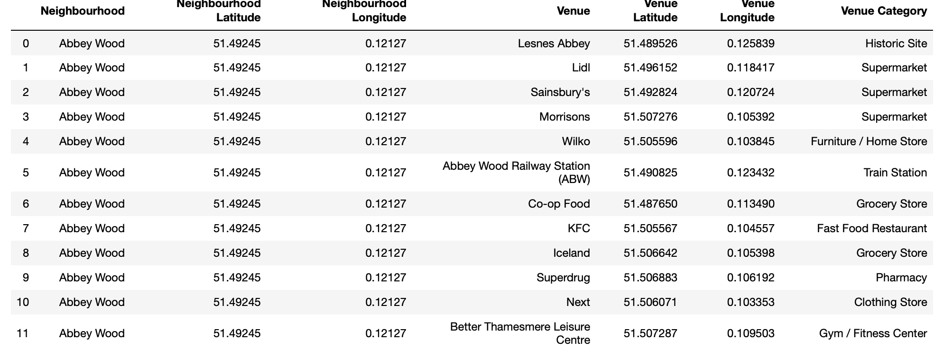

## Methodology

Here I can start to play around with the data and have a look at what information Foursquare has made available to me.

I started by breaking the data down by neighbourhoods; looking at how many venues are in each location. This shows which areas of London may have more going on compared to quieter settings with less to do.

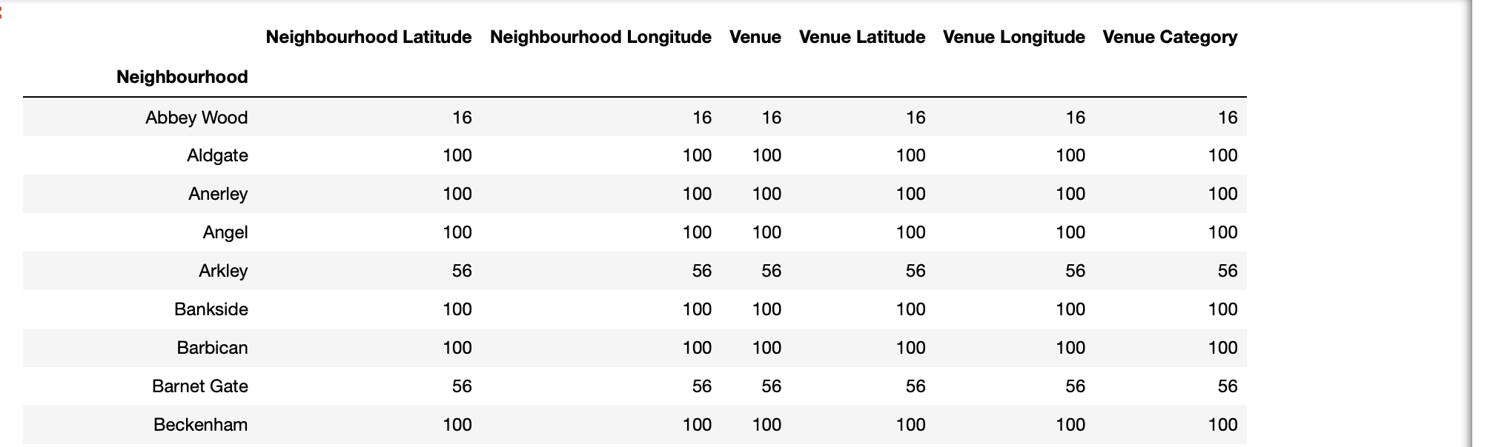

I could then look at the number of venues across all neighbourhoods. To make it the data easier to understand, I use a simple bar chart to visualise it.

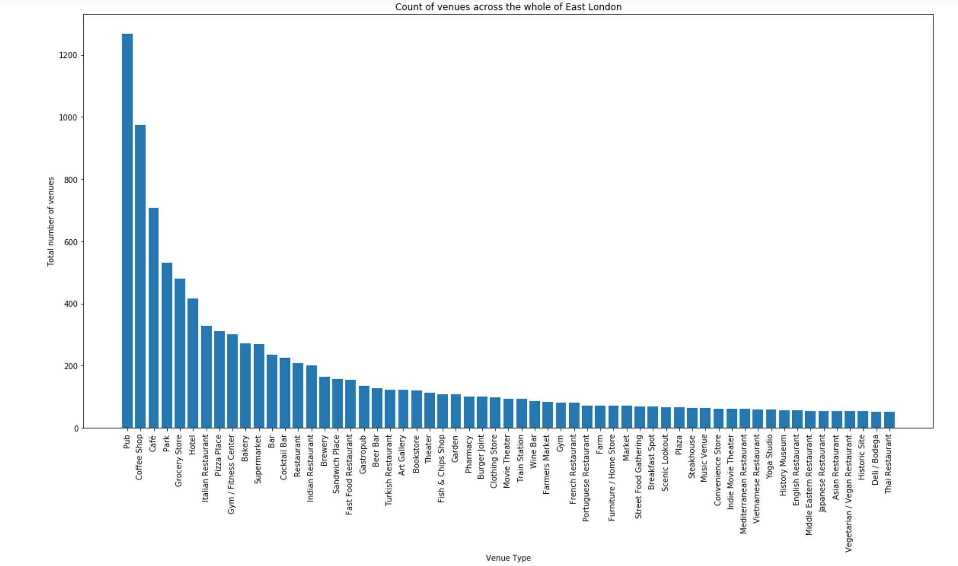

Looking back at the requirements set out by BrightMindsDS I can assess whether they are realistic, e.g. if across all neighbourhoods there are only 2 parks, this requirement may be difficult to fulfil. Fortunately, all venues fitting the criteria listed by the company had a high total count across East London.

These methods offer a lovely breakdown of the collected Foursquare data. There is a wide variety of venues with a great mix of categories. From this I can see all varieties of venues that are in BrightMindsDS' criteria have at least 50 individual sites in East London. This means I have a decent amount of data to help determine the best locations available.

To make sure I have only relevant data to cluster, I am going to section my dataset based on the requirements set by the company:

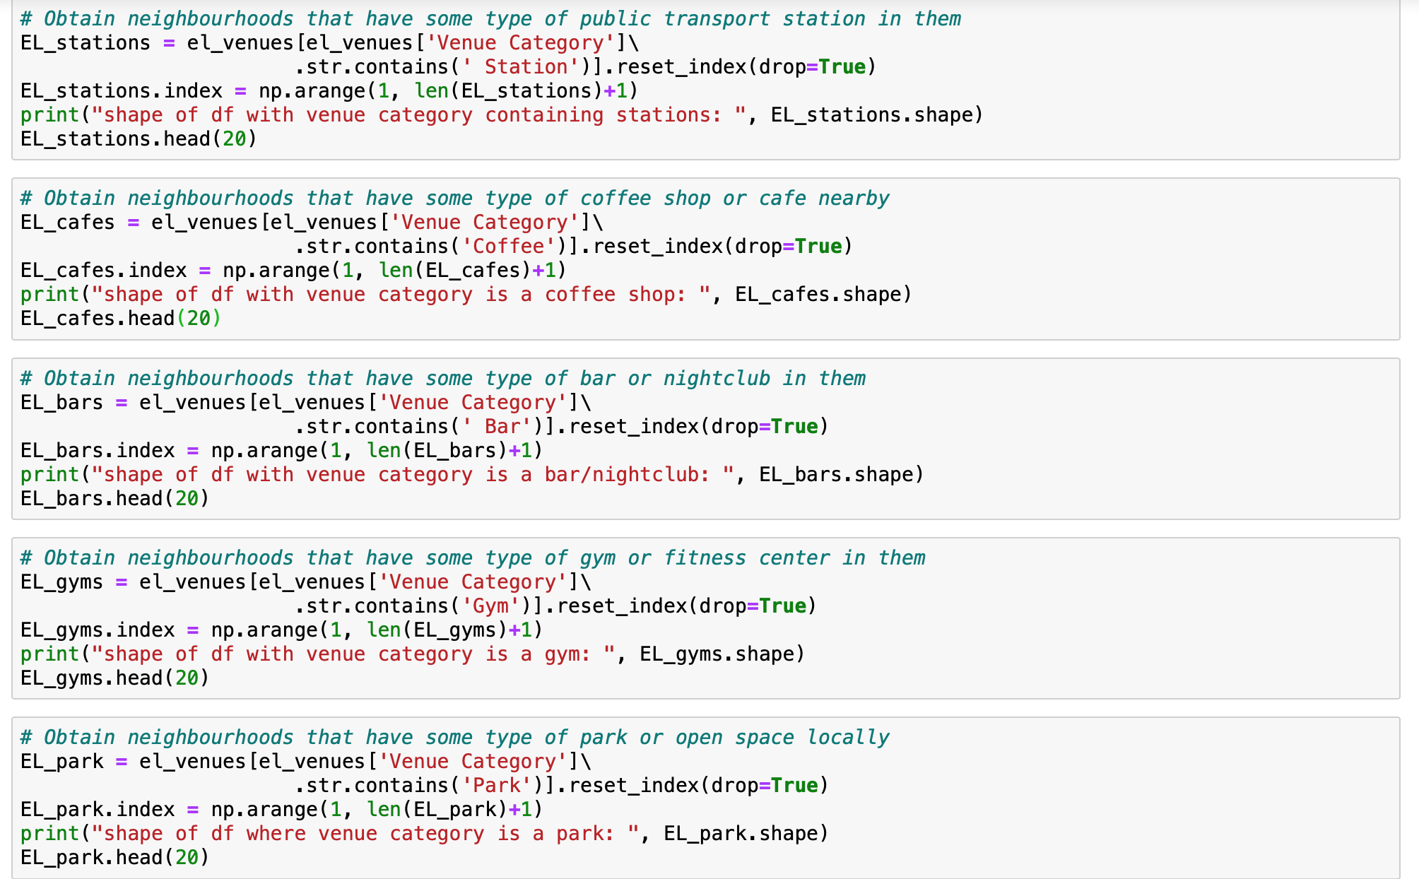

This was another example of **data cleaning**. I realised all data related to venues like museums, stadiums or zoos etc wasn't relevant and could negatively influence the machine learning model. This way I could only look at neighbourhoods that met a least 1 of the requirements. Saving time and resources spent looking at locations that couldn't satisfy the company.

I sorted the list alphabetically by neighbourhood. Although very simple, doing this helped obtain a clearer picture of what venues can be found in each neighbourhood. I broke this down further by looking at a count of unique venue categories per Neighbourhood. I visualised this using stacked bar graph.

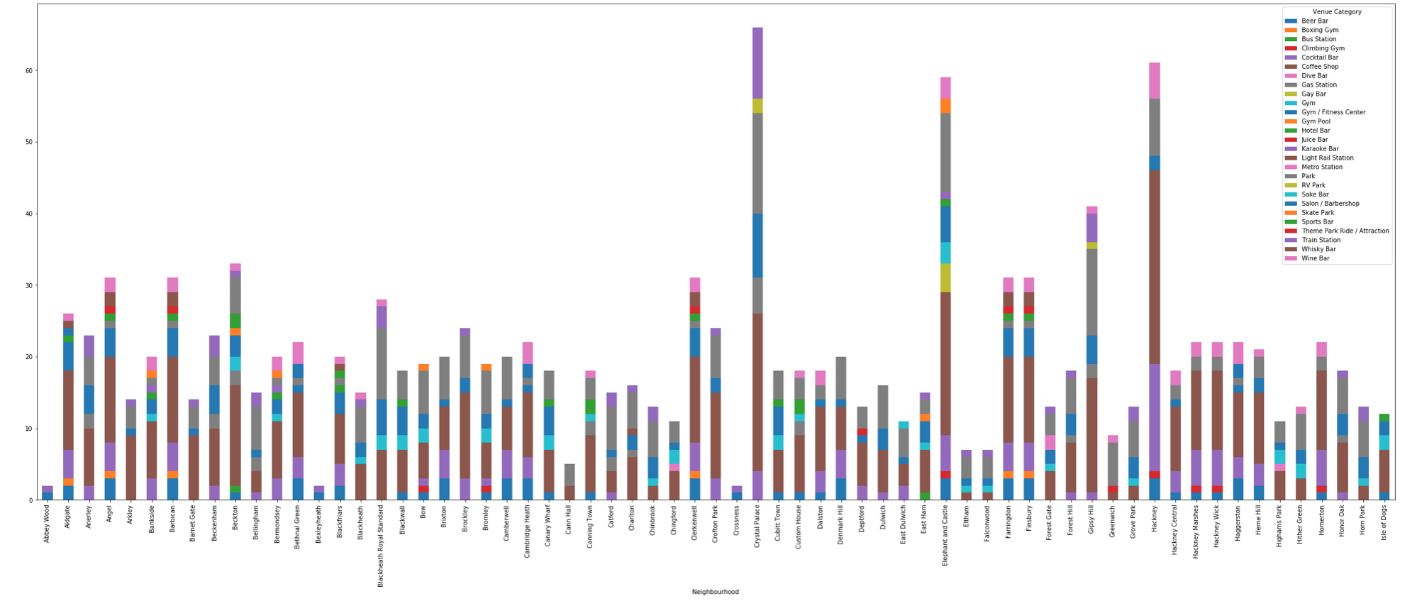

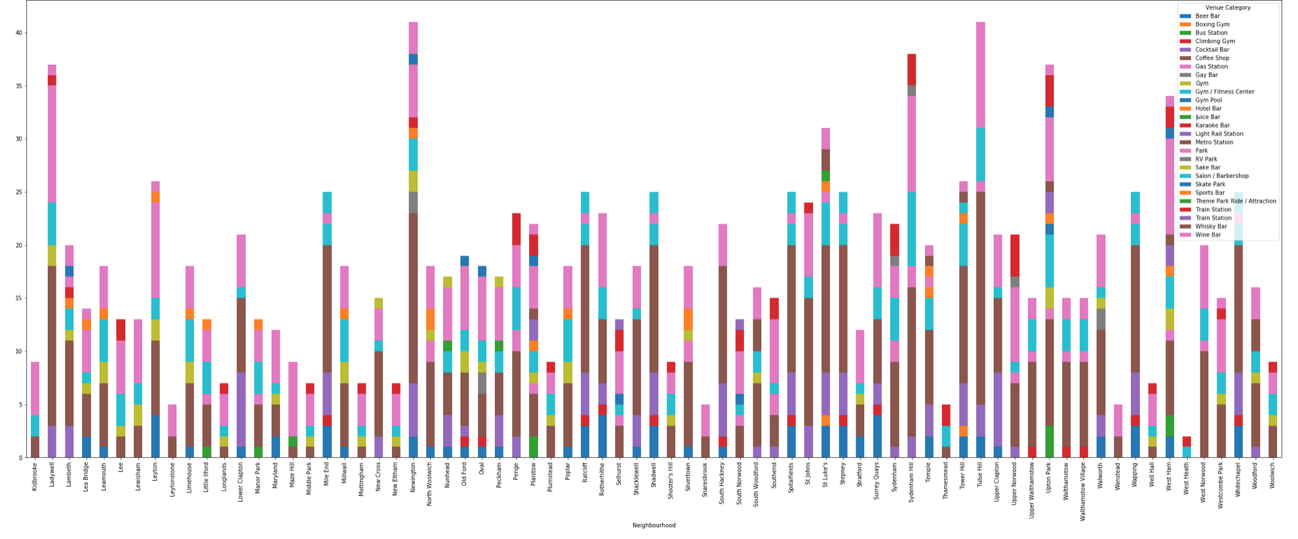

Stacked bar charts are a great way to visualise trends and outliers. In this occasion, you can see Gay Bars do not appear very often, Elephant and Castle seems to have the largest count. Using the coloured keys, it can be a nice way to pick out important information quickly. Due to the wide variety of venues it can be used for multiple purposes too.

### Distance Calculations

Using the **Haversine function** I was able to calculate the distance between each venue and the respective neighbourhood.

*The haversine formula is an equation important in navigation, giving great-circle distances between two points on a sphere from their longitudes and latitudes. It is a special case of a more general formula in spherical trigonometry, the law of haversines, relating the sides and angles of spherical "triangles".*

https://rosettacode.org/wiki/Haversine_formula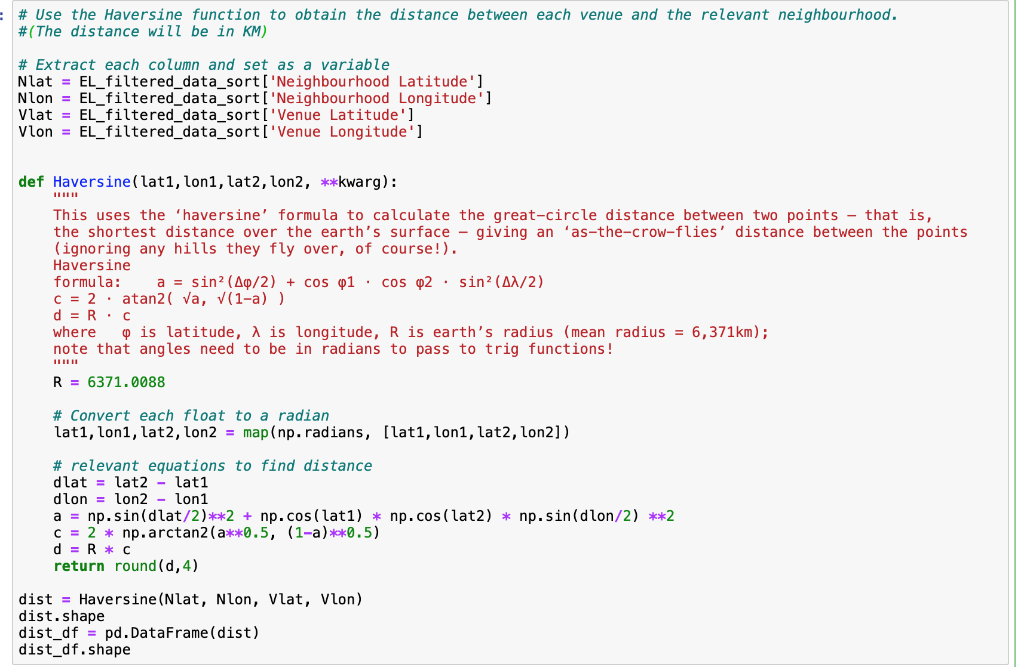

I did this not for the model, but as a good point of reference. If stuck between a choice of locations or unsure if a nightclub would be better than a pub, using distance can make the decision easier for BrightMindsDS. The more information you can give to a client the better the relationship will be.

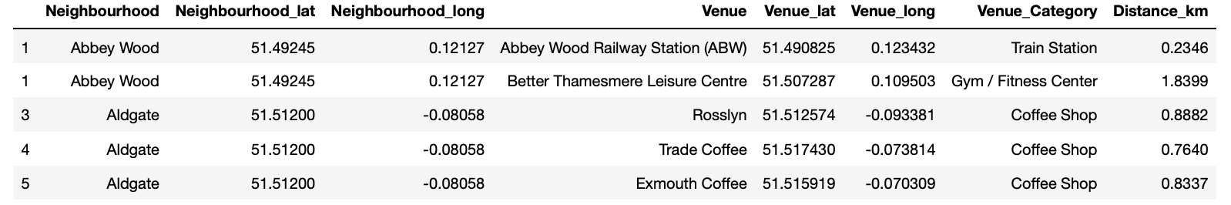

## One-hot Encoding

Many machine learning algorithms cannot operate on label data directly. They require all input variables and output variables to be numeric. In general, this is mostly a constraint of the efficient implementation of machine learning algorithms rather than hard limitations on the algorithms themselves.

<https://machinelearningmastery.com/why-one-hot-encode-data-in-machine-learning/>

This means that categorical data must be converted to a numerical form. Hence the need for **One-hot encoding**. One-hot encoding assigns common variables their own vector and gives them a value of 1 or 0. The length of these vectors is equal to the number of classes or categories the model is expected to classify. As a result, the more variables in a column will now correspond with how often the variable appears in the vector.

Using my data as an example, each row is considered to be a vector. It will loop through the data set and assign a 1 to that column if the venue is associated with the respective neighbourhood or a 0 if not. Now all data is numerical, it can be inserted into a Machine Learning model. It will provide further insights into what is on offer in each neighbourhood.

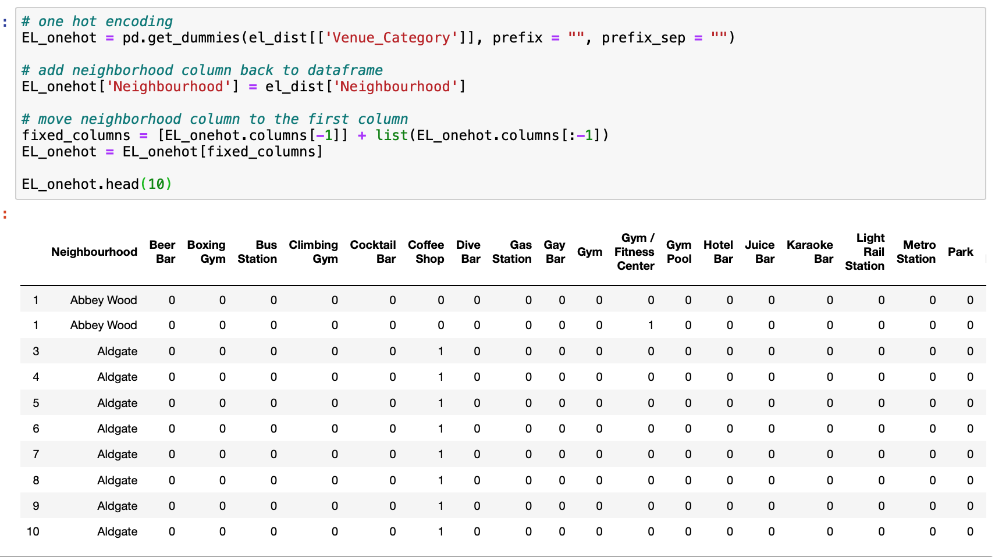

From this I could obtain the top 5 venue categories per neighbourhood. This played a big role in determining how the neighbourhoods would be clustered.

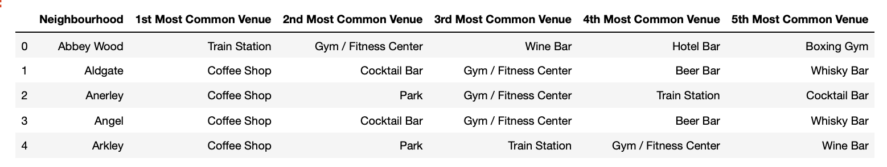

Now we can see what venues are most popular per neighbourhood. This data has been retrieved from Foursquare limiting bias for or against specifics venues or venue types. Inputing this data for the KMeans Clustering algorithm will help distinguish patterns and similarities between neighbourhoods, hopefully offering BrightMindsDS a range of suitable locations.

## KMeans Clustering

### What is it?

K-Means Clustering is an unsupervised machine learning algorithm. In contrast to traditional supervised machine learning algorithms, K-Means attempts to classify data without having first been trained with labelled data. Once the algorithm has been run and the groups are defined, any new data can be easily assigned to the most relevant group.

<https://towardsdatascience.com/machine-learning-algorithms-part-9-k-means-example-in-python-f2ad05ed5203>

### How does it work?

1. Select K (i.e. 2) random points as cluster centers called centroids
2. Assign each data point to the closest cluster by calculating its distance with respect to each centroid
3. Determine the new cluster center by computing the average of the assigned points
4. Repeat steps 2 and 3 until none of the cluster assignments change

### Choosing the right number of clusters – Elbow Method

Often, the data you’ll be working with will have multiple dimensions making it difficult to visualise. As a consequence, the optimum number of clusters is hard to determine. Fortunately, I can use a mathematical way to determine this. I can graph the relationship between the number of clusters and Within Cluster Sum of Squares (WCSS), then by selecting the number of clusters where the change in WCSS begins to level off (elbow method). I have produced this graphically and can be seen below:

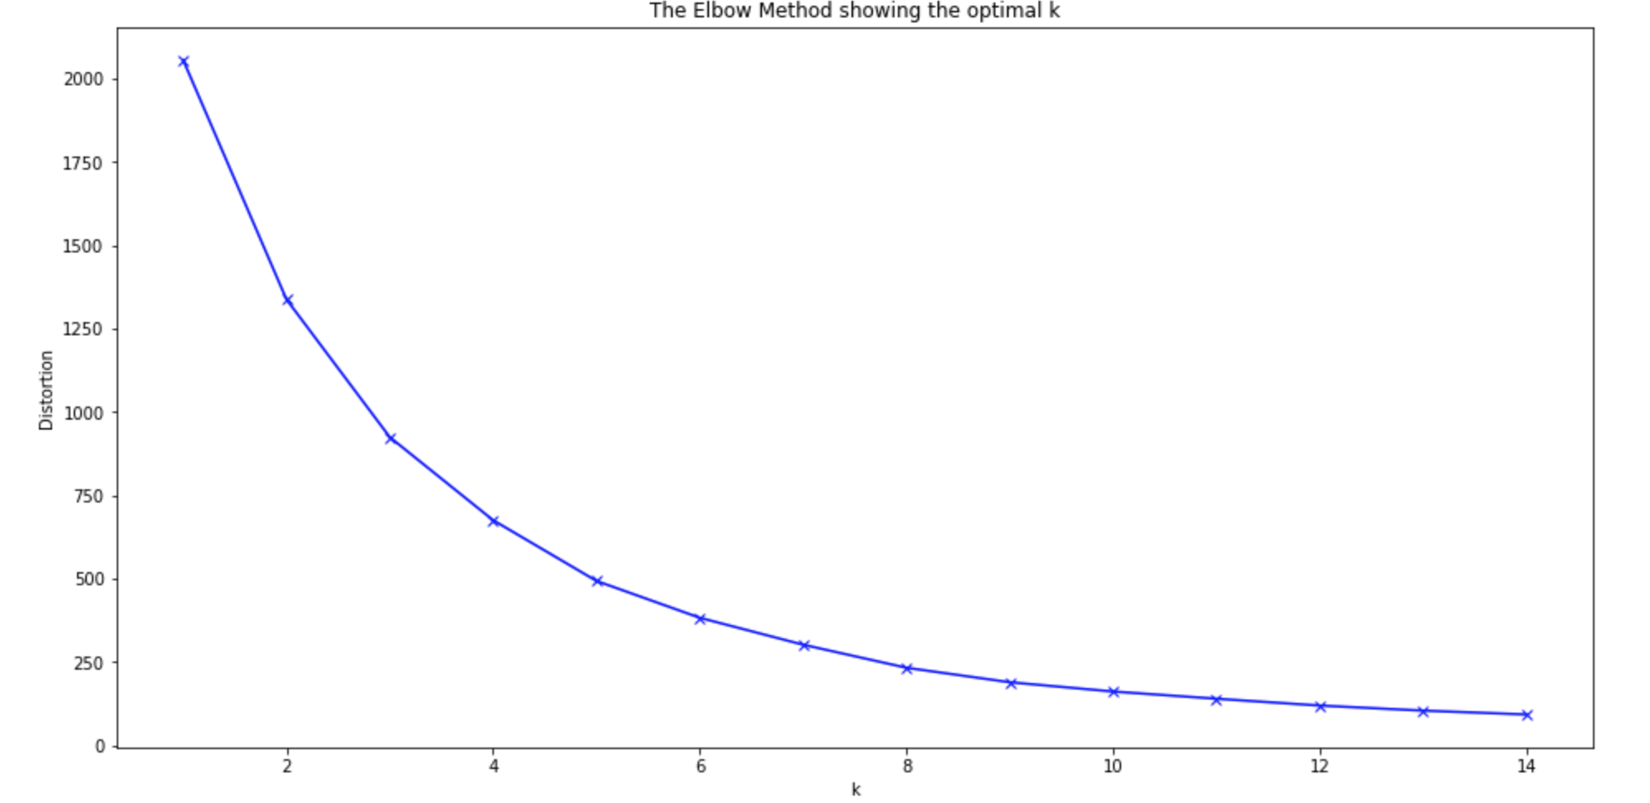

From this plot I could infer that the ‘elbow’ was most prominent when k=5. Due to this fact, I used 5 clusters in my algorithm.

As can be seen in the output, each neighbourhood has a new column attributed to it: *‘Cluster labels’*. This states what cluster the algorithm has assigned that neighbourhood too.

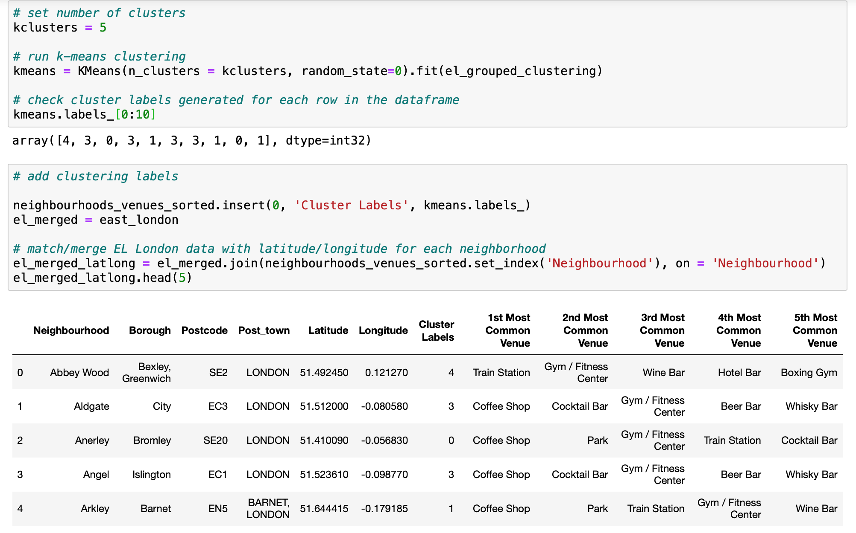

## Results

Visualise the clusters on the map using folium - coloured keys help to determine what neighbourhoods are similar and fall into what cluster.

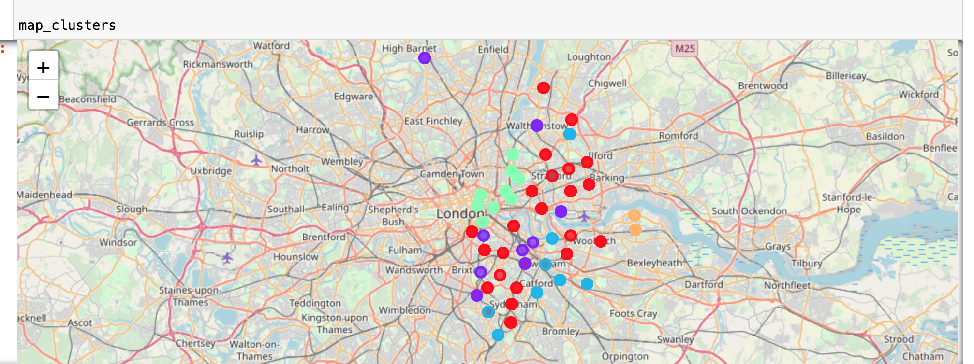

As the colours do not all stick to one location, you can infer that their attributes are similar and follow a trend, rather than situated near each other.

### Breakdown of each cluster

This enables us to get a clearer view of how each cluster was formed; determine similarities and trends within the data that lead the model to create these clusters.

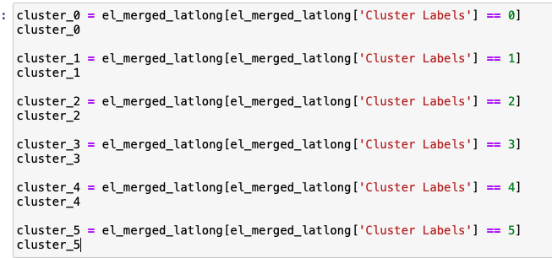

### Discussion

Looking at the individual clusters, the data sets are very similar, however it is the order and frequency that plays a big role in deciding which clusters are better suited to BrightMindsDS criteria. Which were as follows:

* Can it be accessed via local transport?
* Are there any gyms nearby?
* Is there a nice park/open space nearby?
* Are there good coffee shops nearby for lunch?
* Are there good bars/nightclubs to socialise in after work?

BrightMindsDS wanted their chosen location to fulfil at least 2 requirements, exploring each cluster it can be seen that all do this. Which asks the question, what was the point? Well this is where our use of the Foursquare API data played a big role, enabling us to see what venues are the most popular/common in that area.

### Cluster 0 – Red

* This cluster is definitely one of the largest, made up of nearly 20 neighbourhoods. This offers BrightMindsDS a variety of locations spread out over the East of London. These neighbourhoods have coffee shops and parks listed as the most common venues. Offering many locations to socialise outside of work. This was seen as a great positive for the company as stated in a recent article 'The beauty of a work café, is that it can be treated as both an area for relaxation and a place of engagement and innovation.' (1) This was one of the highest priorities for BrightMindsDS; generating innovation and offering a place to relax and take a break. The 3rd, 4th and 5th most common venues are made up of a variety of bars, gyms and most importantly transport stations. Bus, train, metro and Gas stations are common in these neighbourhoods. Travel in and around London will be essential for a rising company. Also, to note, hotel bars and gay bars are listed too; suggesting inclusive cultures and possible venues for clients to stay.

**Based on these factors Neighbourhoods in cluster 2 meet and go beyond BrightMindsDS expectations.**

### Cluster 1 - Purple

* Within these neighbourhoods, coffee shops and parks were the most popular venues. Suggesting good locations to socialise outside of work. This was seen as a great positive for the company (explained above). However, there is very little mention of any local transportation. The realism of working in a big city like London is that employees will need to travel around the city to meet clients and/or commute. This means the neighbourhoods in cluster 1 will have to be ignored.

### Cluster 2 – Light Blue

Looking at the data for cluster 2 I can see that:

* Park is most common, good space to take a break, promote some outdoor team activities or working
* Train station is also listed as one of the most common venues suggesting good rail and underground links which is great for commuters or when visiting clients.
* Gym, boxing gym and gym pool mentioned, providing a different experience aside from a weights or cardio gym.
* There are variety of bars on offer too.

**Based on these factors Neighbourhoods in cluster 2 meet and go beyond BrightMindsDS expectations.**

### Cluster 3 – Green

* Very similar to neighbourhoods in cluster 1; coffee shops and bars are very common; skate parks and fitness centres offer great facilities for BrightMindsDS employees to stay active. Promoting an active lifestyle and a good work-life balance. However, there is no mention of a bus or train station in the vicinity. As mentioned previously, city links and having the option to travel easily is essential to building a steady business. This requirement is a must so these neighbourhoods should be ignored.

### Cluster 4 - Orange

* These 2 neighbourhoods offer good transport links and quite an active location with a gym considered to be the 2nd most common venue. Again, seeing hotel bars suggests that clients can have a place to stay near the office which is a great feature. However, there is no data to suggest that a park or open space can be found within the radius of that location. This limits outdoor activities and could inhibit creativity, meaning neighbourhoods in cluster 4 should not be considered.

(1) <https://www.blueprintinteriors.com/office-work-cafe/>

## Conclusion

**Looking at these results I would recommend any Neighbourhood classed in cluster 0 or cluster 2.**

Both fulfil all requirements set out by BrightMindsDS; offering open spaces for employees to relax, recuperate and socialise as a team, have a variety of bars and gyms to escape to if work gets busy. As the company builds and secures more clients, more and more relationships will need to be made, stress may build up and long hours will need to be worked. Providing their employees with a nice office space in an ideal location is essential to improve employee morale and creativity. Making sure they are situated in an up and coming location will reflect well to potential clients and employees alike.

Further evaluation could have explored office space prices based on location, or reviews of the venues nearby. Foursquare provides so much data it has been very interesting to explore.